1️⃣ Computer Network Basics

Definition
Computer Network = multiple computers/devices connected together to share data and resources.
Examples
- Internet
- Office LAN
- College WiFi

Why networks needed
- Data sharing
- Resource sharing (printer, storage)
- Communication (email, chat, video)
👉 Example
Tum laptop se website open karte ho → tumhara device server se network ke through communicate karta hai.

2️⃣ Types of Networks
Network ko coverage area ke basis par divide kiya jata hai.
Type | Full Form | Range | Example
LAN | Local Area Network | Small area | Office, home WiFi
MAN | Metropolitan Area Network | City level | City ISP network
WAN | Wide Area Network | Large area | Internet

Example Flow
Laptop → Home WiFi (LAN) → ISP network (MAN/WAN) → Google server

3️⃣ Network Components
Network banane ke liye kuch hardware components use hote hain.

1️⃣ Router
- Different networks connect karta hai
- Internet access deta hai
Example
Home router → ISP network

2️⃣ Switch
- Same network ke devices connect karta hai
- LAN me use hota hai
Example
Office computers

3️⃣ Hub
- Basic device jo sabko data broadcast karta hai
- Intelligent nahi hota

4️⃣ Modem
- Digital ↔ analog conversion karta hai
- ISP connection ke liye

5️⃣ End Devices
- Laptop
- Mobile
- Servers

4️⃣ Network Topology
Topology = network ka structure ya layout

Types

Bus Topology
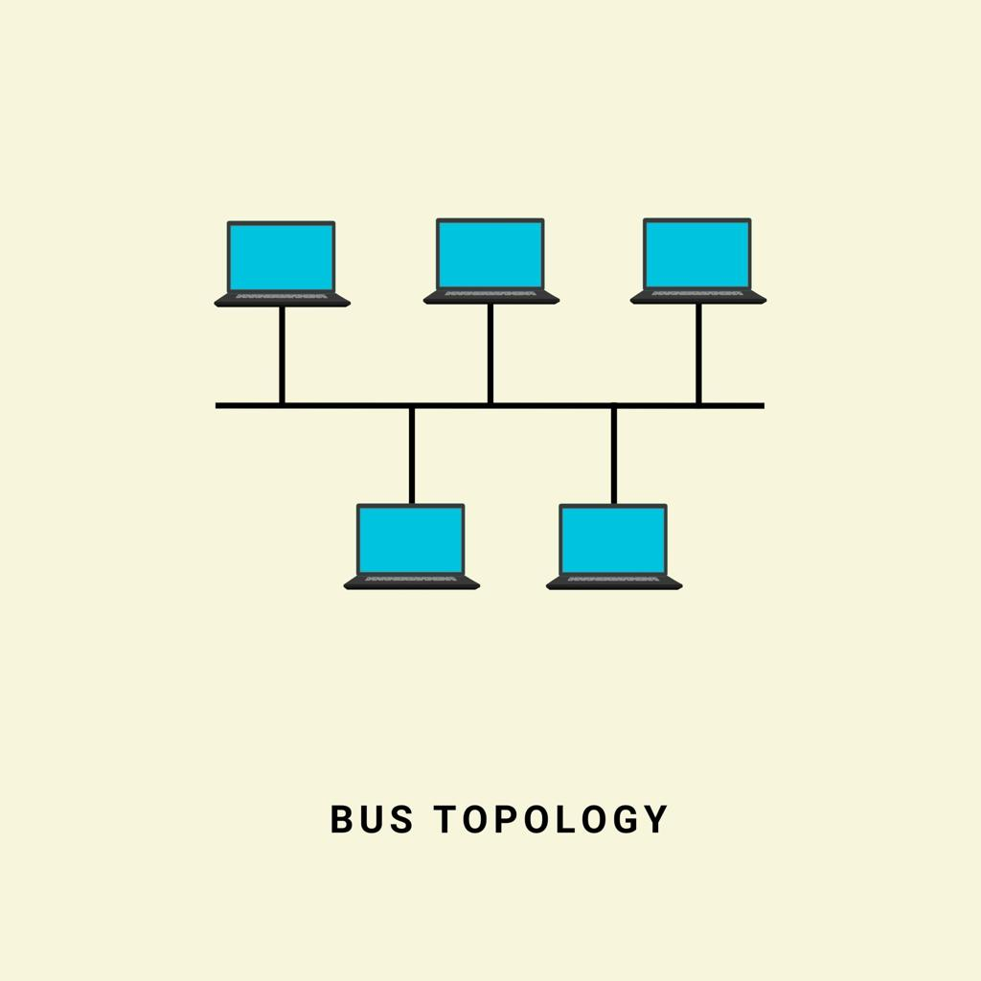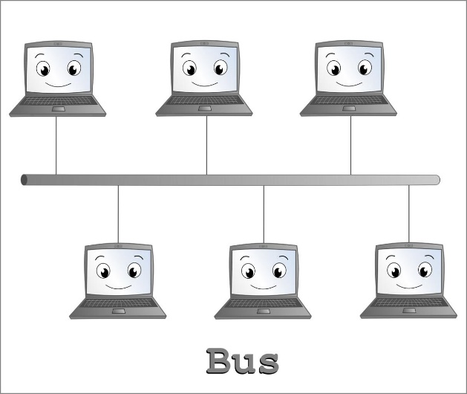

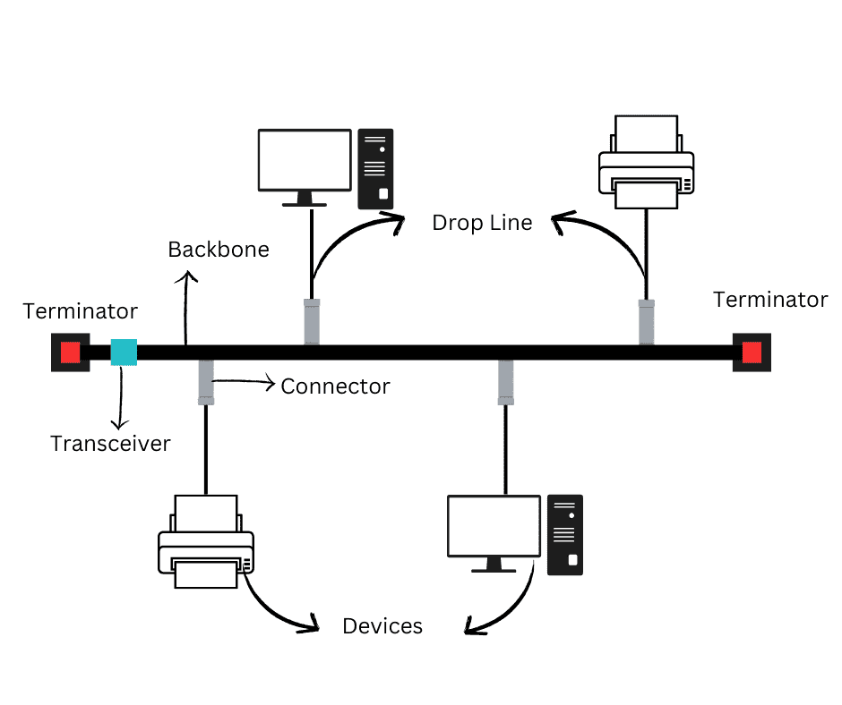
4
- Single cable backbone
- All devices connected to it
Pros
- Cheap
Cons
- Backbone failure → entire network down

Star Topology
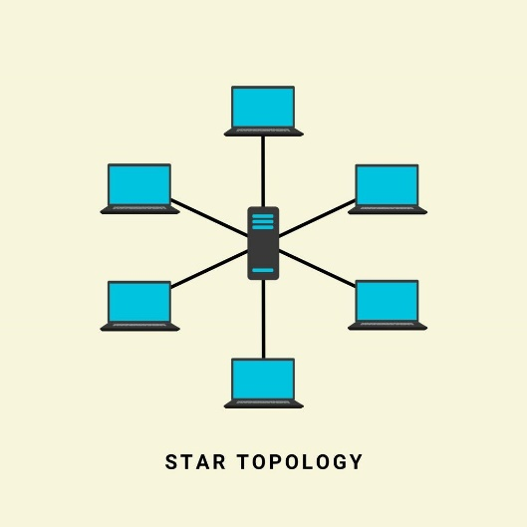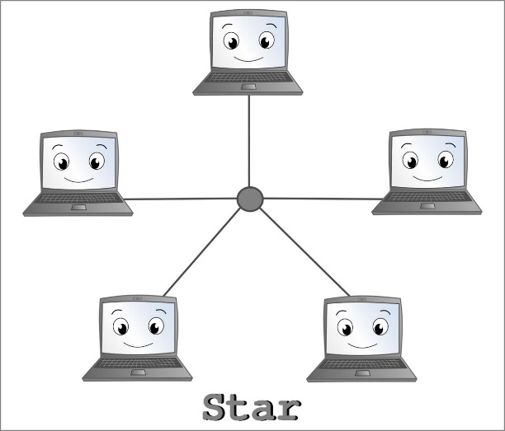

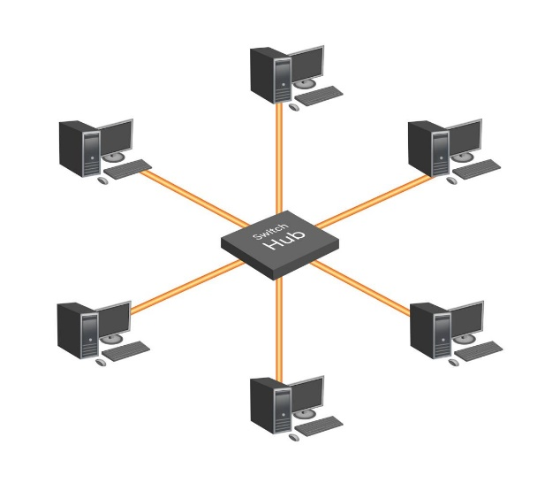
- Central device (switch/router)
- Most common today
Pros
- Easy management
Cons
- Central device failure → network down

Mesh Topology
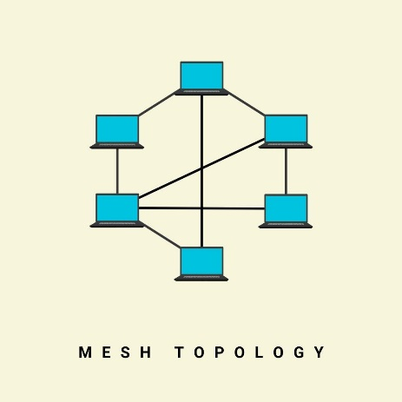
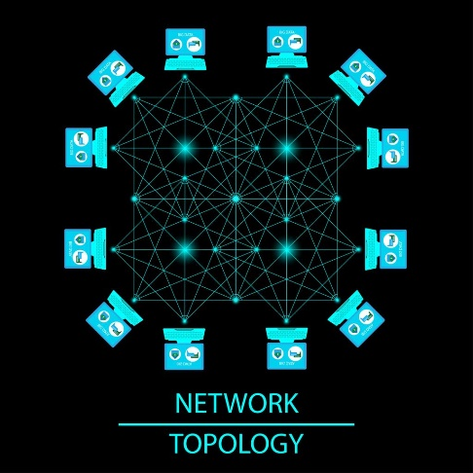
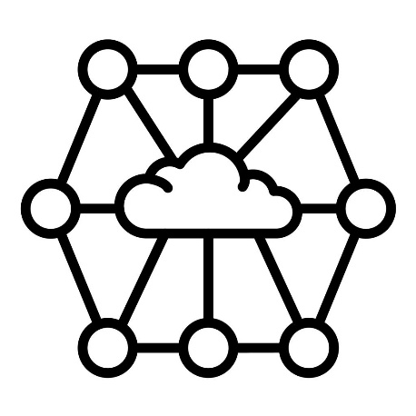
- Every device connected to multiple devices
Pros
- High reliability
Cons
- Expensive

5️⃣ Bandwidth vs Latency vs Throughput
Very common SDE interview question.

Bandwidth
Maximum data capacity.
Example
100 Mbps connection.

Latency
Time taken for data to travel from source → destination.
Example
Ping time = 20 ms.

Throughput
Actual data transferred per second.
Example
Bandwidth = 100 Mbps
Throughput = 60 Mbps

Easy Analogy
Internet = highway
Concept | Example
Bandwidth | Road width
Latency | Travel time
Throughput | Actual cars per second

6️⃣ Packet vs Frame
Data network me chhote pieces me travel karta hai.

Packet
- Network layer data unit
- IP addressing hota hai
Example
Internet packet

Frame
- Data link layer unit
- MAC address use karta hai
Example
Ethernet frame

Flow
Application Data
↓
Packet (Network layer)
↓
Frame (Data link layer)
↓
Bits (Physical layer)

7️⃣ Circuit Switching vs Packet Switching

Circuit Switching
Dedicated connection.
Example
Old telephone system
Steps
1 connection establish
2 communication
3 connection close
Problem
- Bandwidth waste

Packet Switching
Internet me use hota hai.
Data → packets me divide → different routes → destination par combine.
Example
Internet traffic
Pros
- Efficient
- Reliable

8️⃣ Duplex Communication
Communication direction define karta hai.
Type | Meaning | Example
Simplex | One way | TV broadcast
Half Duplex | One at a time | Walkie talkie
Full Duplex | Both directions | Phone call
Internet mostly full duplex hota hai.

9️⃣ MAC Address Basics
MAC Address = unique hardware address of a device
Example
00:1A:2B:3C:4D:5E
Properties
- 48-bit address
- Network card me stored
- Data link layer pe use hota hai
Use
- Local network communication

🔟 Network Protocols
Protocol = rules of communication between devices
Examples
Protocol | Work
HTTP | Web communication
HTTPS | Secure web
TCP | Reliable data transfer
UDP | Fast but unreliable
IP | Addressing
DNS | Domain → IP conversion

🧠 Sab Concepts Ka Relationship (Most Important)
Full communication flow:
1️⃣ Device (Laptop)
↓
2️⃣ Router / Switch (Network Components)
↓
3️⃣ Network Type (LAN/WAN)
↓
4️⃣ Data split into Packets
↓
5️⃣ Packets wrapped into Frames
↓
6️⃣ MAC Address used in local network
↓
7️⃣ IP Protocol used for routing
↓
8️⃣ Data transfer speed defined by
- Bandwidth
- Latency
- Throughput

💡 Real Example (Interview Ready)
Tum browser me type karte ho:
google.com
Steps
1 DNS → domain → IP
2 Data → packets me split
3 Frames me convert
4 Router → Internet → Google server
5 Response back

✅ Ye Computer Network ka base layer hai jo almost har SDE interview me pucha jata hai.

